Set icon and background of ActionBar

Android programming example to set icon and background of ActionBar. (Assume your activity extends android.support.v7.app.ActionBarActivity, with android.support.v7.app.ActionBar)

[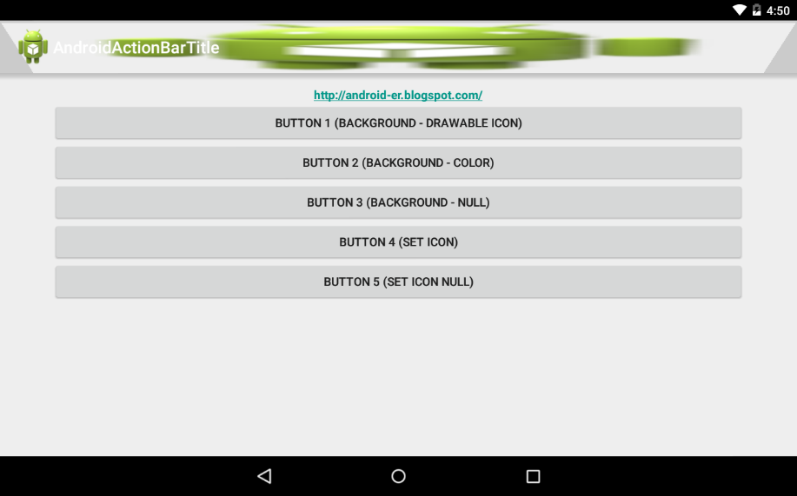](http://1.bp.blogspot.com/-avx-NdPGwD0/VSwtSbYLYNI/AAAAAAAANEU/CQMTSomL2gI/s1600/AndroidActionBarTitle.png)

package com.example.androidactionbartitle;

import android.support.v7.app.ActionBar;

import android.support.v7.app.ActionBarActivity;

import android.view.View;

import android.view.View.OnClickListener;

import android.widget.Button;

import android.content.res.Resources;

import android.graphics.drawable.ColorDrawable;

import android.graphics.drawable.Drawable;

import android.os.Bundle;

public class MainActivity extends ActionBarActivity {

Button btn1, btn2, btn3, btn4, btn5;;

@Override

protected void onCreate(Bundle savedInstanceState) {

super.onCreate(savedInstanceState);

setContentView(R.layout.activity_main);

btn1 = (Button)findViewById(R.id.button1);

btn2 = (Button)findViewById(R.id.button2);

btn3 = (Button)findViewById(R.id.button3);

btn4 = (Button)findViewById(R.id.button4);

btn5 = (Button)findViewById(R.id.button5);

btn1.setOnClickListener(new OnClickListener(){

@Override

public void onClick(View v) {

ActionBar actionBar = getSupportActionBar();

Drawable drawable;

Resources resources = getResources();

//deprecated in API level 22

//drawable = resources.getDrawable(R.drawable.ic_launcher);

//API Level 21

drawable = resources.getDrawable(R.drawable.ic_launcher, null);

actionBar.setBackgroundDrawable(drawable);

}});

btn2.setOnClickListener(new OnClickListener(){

@Override

public void onClick(View v) {

ActionBar actionBar = getSupportActionBar();

Drawable drawable;

drawable = new ColorDrawable(0xA0500050);

actionBar.setBackgroundDrawable(drawable);

}});

btn3.setOnClickListener(new OnClickListener(){

@Override

public void onClick(View v) {

ActionBar actionBar = getSupportActionBar();

actionBar.setBackgroundDrawable(null);

}});

btn4.setOnClickListener(new OnClickListener(){

@Override

public void onClick(View v) {

ActionBar actionBar = getSupportActionBar();

Drawable drawable;

Resources resources = getResources();

//deprecated in API level 22

//drawable = resources.getDrawable(R.drawable.ic_launcher);

//API Level 21

drawable = resources.getDrawable(R.drawable.ic_launcher, null);

actionBar.setIcon(drawable);

actionBar.setDisplayShowHomeEnabled(true);

}});

btn5.setOnClickListener(new OnClickListener(){

@Override

public void onClick(View v) {

//enable display HOME, but with icon of null

ActionBar actionBar = getSupportActionBar();

actionBar.setIcon(null);

actionBar.setDisplayShowHomeEnabled(true);

}});

}

}

<LinearLayout xmlns:android="http://schemas.android.com/apk/res/android"

xmlns:tools="http://schemas.android.com/tools"

android:layout_width="match_parent"

android:layout_height="match_parent"

android:orientation="vertical"

android:paddingBottom="@dimen/activity_vertical_margin"

android:paddingLeft="@dimen/activity_horizontal_margin"

android:paddingRight="@dimen/activity_horizontal_margin"

android:paddingTop="@dimen/activity_vertical_margin"

tools:context="com.example.androidactionbartitle.MainActivity" >

<TextView

android:layout_width="wrap_content"

android:layout_height="wrap_content"

android:layout_gravity="center_horizontal"

android:autoLink="web"

android:text="http://android-er.blogspot.com/"

android:textStyle="bold" />

<Button

android:id="@+id/button1"

android:layout_width="match_parent"

android:layout_height="wrap_content"

android:text="Button 1 (background - drawable icon)"/>

<Button

android:id="@+id/button2"

android:layout_width="match_parent"

android:layout_height="wrap_content"

android:text="Button 2 (background - color)"/>

<Button

android:id="@+id/button3"

android:layout_width="match_parent"

android:layout_height="wrap_content"

android:text="Button 3 (background - null)"/>

<Button

android:id="@+id/button4"

android:layout_width="match_parent"

android:layout_height="wrap_content"

android:text="Button 4 (set icon)"/>

<Button

android:id="@+id/button5"

android:layout_width="match_parent"

android:layout_height="wrap_content"

android:text="Button 5 (set icon null)"/>

</LinearLayout>